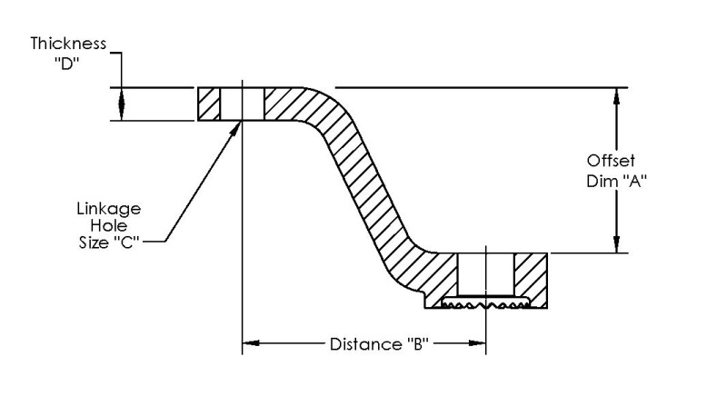
Default levers Delivered on Silver hawk Servos
KIT SERVO THROTTLE LEVER MIXTURE LEVER
EX235-1 3015020-1 2521287 2521196
EX235-2 3015022-1 2521287 2521196
EX320-1 3015008-1 2521196 2521287
EX320-2 3015014-1 2521196 2521287
EX360-1 3015002-1 2521196 2522004
EX360-2 3015006-1 2521196 2521287
EX360-3 3015010-1 2521196 2521287
EX360-4 3015012-1 2521196 2521287
EX360-5 3015002-1 2521196 2522004
EX390-1 3015018-1 2522004 2521196
EX540-1 3015006-1 2521196 2521287
EX540-2 3015012-1 2521196 2521287
EX540-3 3015016-1 2521196 2523899

Dimensions of common levers
Part Number offset “A” Distance “B” Hole size “C” Thickness “D”
2521196 0.938 2.00 0.1935 0.187
2521287 0.938 1.625 0.1935 0.187
2522004 0 1.625 0.1935 0.187
2523899 0.938 1.38 0.1935 0.187

